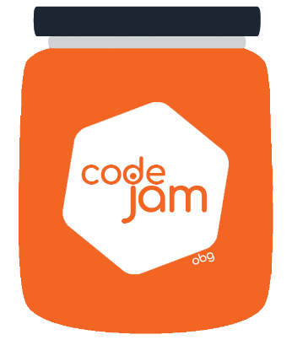

Challenge 2: Dog Body

Task merged and passed QA all seemed good till the time the same PO rushing to the team’s area asking for help. The brand team needs also a body for the dog head you created and they need it as soon as possible to be in the next release. You knew that deep down that the specs would change. You prepare yet again to code the rest of this hard to believe request….

What you need to do:

1. Time to complete is 30min
2. Each team member has 10min to code.
3. The rest of the team can assist without coding (helping, giving ideas).
4. Create a Dog body to fit the head you created.
5. You can shrink or move the head you created to fit the body
6. In case the head was not complete you can complete it in the given time (together with the body).
7. The dog should be created purely with HTML/CSS and without the use of any images (bitmap or vector) or canvas element.
8. You can use any properties from CSS and anything that help you to do that.